## Connect to the virtual machine

1. If you haven't already done so, sign in to the [Azure portal](https://portal.azure.com/).
2. In the left menu, click **Virtual Machines**.
3. Select the virtual machine from the list.
4. On the page for the virtual machine, click **Connect**.

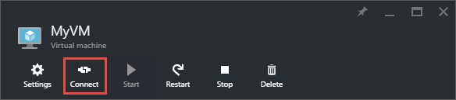

Create a Windows virtual machine with the Azure portal

## Log in to Azure

Log in to the Azure portal at [https://portal.azure.com](https://portal.azure.com/).

## Create virtual machine

1. Click **Create a resource** in the upper left-hand corner of the Azure portal.
2. Select **Compute**, and then select **Windows Server 2016 Datacenter**.
3. Enter the virtual machine information. The user name and password entered here is used to log in to the virtual machine. The password must be at least 12 characters long and meet the [defined complexity requirements](https://docs.microsoft.com/en-us/azure/virtual-machines/windows/faq#what-are-the-password-requirements-when-creating-a-vm). When complete, click **OK**.

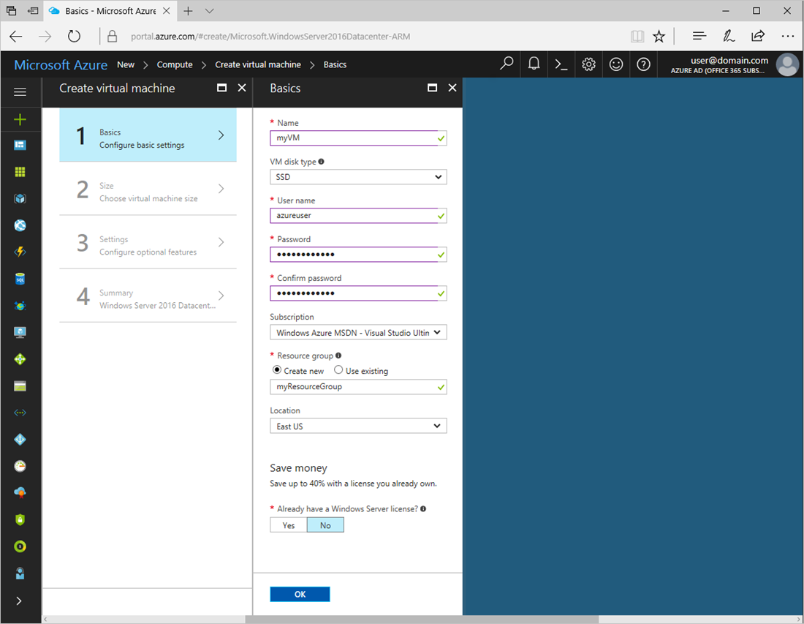

1. Select a size for the VM. To see more sizes, select **View all** or change the **Supported disk type** filter.

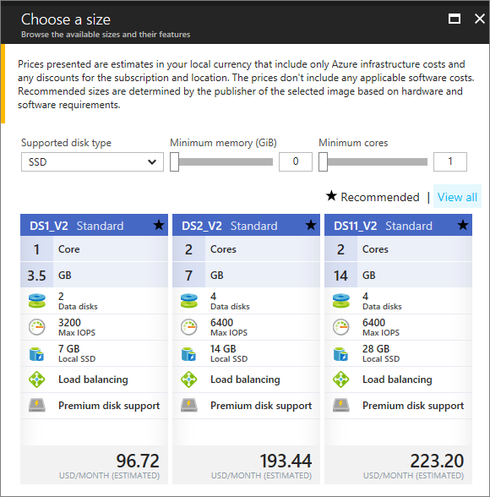

1. Under **Settings**, keep the defaults and click **OK**.
2. On the summary page, click **Ok** to start the virtual machine deployment.
3. The VM will be pinned to the Azure portal dashboard. Once the deployment has completed, the VM summary automatically opens.

## Connect to virtual machine

Create a remote desktop connection to the virtual machine.

1. Click the **Connect** button on the virtual machine properties. A Remote Desktop Protocol file (.rdp file) is created and downloaded.

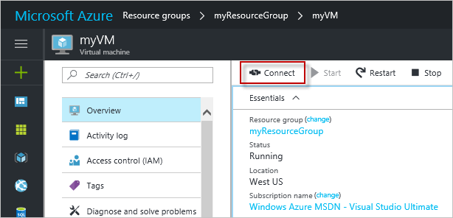

1. To connect to your VM, open the downloaded RDP file. If prompted, click **Connect**. On a Mac, you need an RDP client such as this [Remote Desktop Client](https://itunes.apple.com/us/app/microsoft-remote-desktop/id715768417?mt=12) from the Mac App Store.
2. Enter the user name and password you specified when creating the virtual machine, then click **Ok**.
3. You may receive a certificate warning during the sign-in process. Click **Yes** or **Continue** to proceed with the connection.

## Install IIS using PowerShell

On the virtual machine, start a PowerShell session and run the following command to install IIS.

PowerShellCopy

Install-WindowsFeature -name Web-Server -IncludeManagementTools

When done, exit the RDP session and return the VM properties in the Azure portal.

## Open port 80 for web traffic

A Network security group (NSG) secures inbound and outbound traffic. When a VM is created from the Azure portal, an inbound rule is created on port 3389 for RDP connections. Because this VM hosts a webserver, an NSG rule needs to be created for port 80.

1. On the virtual machine, click the name of the **Resource group**.
2. Select the **network security group**. The NSG can be identified using the **Type** column.
3. On the left-hand menu, under settings, click **Inbound security rules**.
4. Click on **Add**.
5. In **Name**, type **http**. Make sure **Port range** is set to 80 and **Action** is set to **Allow**.
6. Click **OK**.

## View the IIS welcome page

With IIS installed, and port 80 open to your VM, the webserver can now be accessed from the internet. Open a web browser, and enter the public IP address of the VM. The public IP address can be found under Virtual Machines in the Azure portal.

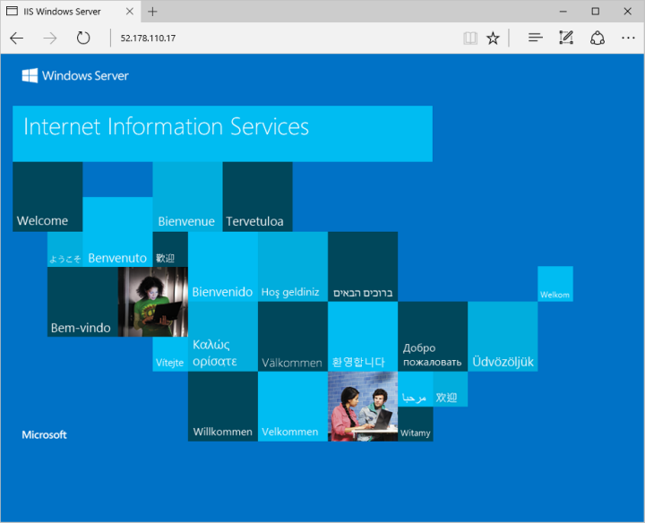

---- Powershell

## Create virtual machine

Create the virtual machine with [New-AzureRmVM](https://docs.microsoft.com/en-us/powershell/module/azurerm.compute/new-azurermvm). You just need to provide names for each of the resources and the New-AzureRMVM cmdlet will create them for you if they don't already exist.

When running this step, you are prompted for credentials. The values that you enter are configured as the user name and password for the virtual machine.

Try It

New-AzureRmVm `

-ResourceGroupName "myResourceGroup" `

-Name "myVM" `

-Location "East US" `

-VirtualNetworkName "myVnet" `

-SubnetName "mySubnet" `

-SecurityGroupName "myNetworkSecurityGroup" `

-PublicIpAddressName "myPublicIpAddress" `

-OpenPorts 80,3389

## Connect to virtual machine

After the deployment has completed, create a remote desktop connection with the virtual machine.

Use the [Get-AzureRmPublicIpAddress](https://docs.microsoft.com/en-us/powershell/module/azurerm.network/get-azurermpublicipaddress) command to return the public IP address of the virtual machine. Take note of this IP Address so you can connect to it with your browser to test web connectivity in a future step.

Try It

Get-AzureRmPublicIpAddress -ResourceGroupName myResourceGroup | Select IpAddress

Use the following command, on your local machine, to create a remote desktop session with the virtual machine. Replace the IP address with the publicIPAddress of your virtual machine. When prompted, enter the credentials used when creating the virtual machine.

Copy

mstsc /v:<publicIpAddress>

## Install IIS via PowerShell

Now that you have logged in to the Azure VM, you can use a single line of PowerShell to install IIS and enable the local firewall rule to allow web traffic. Open a PowerShell prompt on the VM and run the following command:

Install-WindowsFeature -name Web-Server -IncludeManagementTools

## View the IIS welcome page

With IIS installed and port 80 now open on your VM from the Internet, you can use a web browser of your choice to view the default IIS welcome page. Be sure to use the publicIpAddress you documented above to visit the default page.



## Clean up resources

When no longer needed, you can use the [Remove-AzureRmResourceGroup](https://docs.microsoft.com/en-us/powershell/module/azurerm.resources/remove-azurermresourcegroup) command to remove the resource group, VM, and all related resources.

Remove-AzureRmResourceGroup -Name myResourceGroup